2 - <https://www.esa.int/>

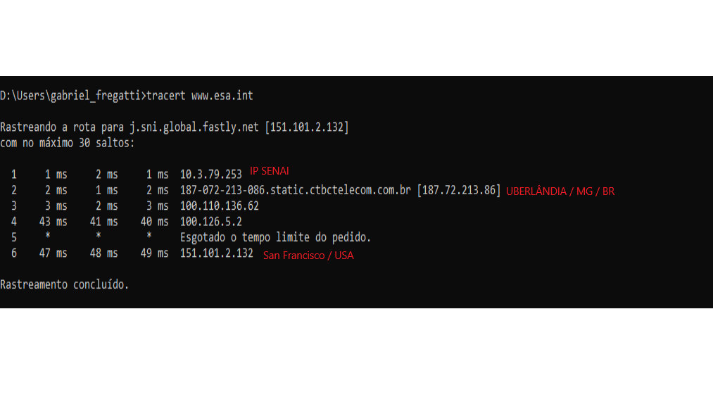

6 - <https://www.gov.za/>

